|  |
| --- |
| Bifurcation Analysis on the Biochemical Switches in the G1-S Transition of the Mammalian Cell Cycle  C. Liu, M. Huang  Department of Biomedical Engineering, University of Southern California |

[1]*abstract

**Motivation:** The G1-S transition of the mammalian cell cycle has been the center of many studies in cancer growth as its proper function is critical to ensure the cell divides without errors. Mathematical modeling of the body of knowledge regarding the regulatory molecules contained in this system can formulate testable hypothesis that can lead to targeted treatments for cancer.

**Results:** Our bifurcation analysis showed that the overexpression of constitutive synthesis rate of cyclin D and/or cyclin E resulted in a negative shift in the threshold level of mitogenic stimulation to form a saddle node bifurcation. This indicates bistability in the system – a key indicator for cell proliferation.

**Conclusion:** This suggests the use of drugs that target the inhibits the expression of Cyclin D and Cyclin E to induce cell cycle arrest on cancer cells.

# introduction

The G1-S transition of cell cycling provides the go signal for DNA synthesis after the cell has grown to a sufficient stage and the requisite processes to continue into cell division have completed. Errors in this go signal has been shown to lead to uncontrolled growth of the cell - a hallmark of cancer. Thus there is a major focus to understand the molecular interactions of this regulatory system. Decades of experimental research has uncovered a range of molecules and interactions involved. Mathematical modeling is used to integrate the existing body of knowledge into a larger framework to describe experimental observations of the overall system. If successful, the model can then be reasonably used to make predictions about effects of manipulating cell regulatory molecules on cell cycling, which suggest treatments to correct cell cycling errors that lead to cancer, as well as to further scientific knowledge.

The present model of the G1-S transition by Hatzimanikatis, et al 1999 can be characterized by a phosphorylation cascade that amplifies a transcription promoter to activate a transcription factor to bring the cell cycle into DNA synthesis - the S phase [1]. This phosphorylation cascade can be characterized as a positive feedback loop that behaves as a biochemical switch to toggle the transcription factor to a higher steady state. While this model has been shown to replicate experimentally observed phenomena, this model only contains one transcription factor promoter, cyclin E. Much evidence demonstrates the overexpression of an additional transcription factor promoter, cyclin D, in several types of tumor formation. Cyclin D is established as an oncogene with an important pathogenetic role in many human tumors [2]. Thus, the mathematical model by Hatzimanikatis is oversimplified and demonstrates an omission of important components in the overall picture.

To overcome this limitation, we extend the model by incorporating the phosphorylation cascade involving cyclin D and its corresponding cyclin-dependent kinases, cdk4/6, as described by [Swat]. Next we determine if this model can be used to describe experimental observations of the effects of overexpressing the constitutive synthesis rates of cyclin D and cyclin E on cell proliferation. If successful, it increases confidence in the model’s ability to suggest drug targets to inhibit cell proliferation, and thus stop tumorigenesis.

# Methods

## The G1/S Bistability Model

The mathematical model of the G1/S transition in mammalian cells is modified based on a previous model proposed by Swat et al. (2004) which includes a set of proteins and their regulatory gene factors. The schematic diagram of the G1/S transition network is provided in Figure 1 and their relationship is presented as differential equations provided in the supplementary material section [Swat].

The model can be summarized by its two phosphorylation cascades involving the cyclin D, cdk4/6 complex and the cyclin E, cdk2 complex that act is biochemical switches to regulate the level of the transcription factor, E2F-1. At beginning of the cell cycle, E2F-1 is bound to the tumor suppressor (pRB). The activated cyclinD-cdk4,6 complex first promote the phosphorylation of pRB and then the activated cyclinE/CDK2 complex promote the reaction of double-phosphorylated pRB from to fully release E2F-1 [Swat]. Moreover, E2F-1 will amplify the signal of the generation of cyclin D, cyclin E, and pRB and cause them to reach a higher stable steady state. The presence of two steady states in the system that toggle from a low steady state (off) to a high steady state (on) is called bistability. The switch-like behavior indicates the start of cell proliferation.

Bistability is a common response of systems containing combination of positive and negative feedback loops.

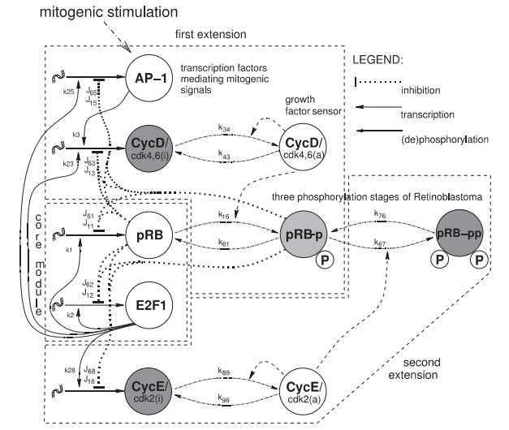

Figure 1. The schematic diagram of cell cycle transition during G0-phase to S-phase

Indeed, these positive and negative feedback regulatory systems are abundant in the G1/S cycle [Bertoli 2013]. In this case, two positive feedback loops trigger a two stage phosphorylation of pRB to free its inhibition onto E2F-1. Fingure X shows the rapid incensement of E2F-1 in a switch like manner to bring it to a higher steady state, and thus committing the cell cycle into cell proliferation, the S phase.



Figure 2. Time course of computed protein bistability behavior

## Modified model to show cell proliferation with oscillation

This model can also be modified to show the oscillatory behavior of cell proliferation that is found in the past model by Hatzimanikatis et al. (1999) [ref Hatz]. We find that the generation of oscillations with the G1-S transition regulatory molecules to be unjustified. The oscillations of cell cycling are generated first with a positive feedback system that brings the transcription factor signal up to commit the cell cycle into the S phase, and then a negative feedback mechanism to bring the transcription factor back down. The model by [ref Hatz] models this with a simple negative feedback from E2F1 back to cyclinE. According to [ref Bertoli 2013], transcriptional repressors present in

## Bifurcation Analysis of the G1/S Transition

The analysis of bifurcations due to the strength of the mitogenic growth signal, Fm, as a bifurcation parameter is used to determine cell proliferation. Low levels of Fm is inadequate to produce CycD to trigger a phosphorylation cascade. In this case, the switching to a second steady state does not occur. As Fm increases past a threshold as indicated through a saddle node bifurcation, the system switches to generate bistability.

## Constitutive Synthesis Rates for Cyclin D and Cyclin E

For the model to describe experiments involving the constitutive overexpression of the synthesis rates of cyclin D and cyclin E [ref][ref], we added a constitutive value, CD and CE, to provide a basal rate of growth for Cyclin D and Cyclin E, respectively.

|  |  |
| --- | --- |
|  | (1) |

|  |  |
| --- | --- |
|  | (2) |

With the constitutive term added, this increases the production rate of CycD and CycE. To bring the system back down to baseline levels as seen in the original model, the E2F-1 concentration dependent constants, k23 and k28, for CycD and CycE, respectively, is decreased.

# results and discussion

## Inclusion of the Constitutive Rate for the production of CycE/CycD

The saddle node bifurcation threshold given variable levels of Fm ­is brought back to baseline through a range of combinations of k23, k28, CD, and CE parameter values.

Conclusions

Initially in the G1 phase, pRB is an inhibitor of tumor growth and the transcription factor, E2F1. Two phosphorylation cascades represented by the two transcription factor promoters, cycD-cdk4,6, and cycE-cdk2 behaves as a positive feedback mechanism. These two positive feedback loops trigger a two stage phosphorylation of pRB to free its inhibition onto E2F-1. This rapidly increases E2F-1 in a switch like manner to bring it to a higher steady state, and thus committing the cell cycle into cell proliferation, the S phase.

acknowledgements

Supplementary materials

References

Swat, M., Kel, A., & Herzel, H. (2004). Bifurcation analysis of the regulatory modules of the mammalian G1/S transition. Bioinformatics, 20, 1506-1511.

1. * mikehuan@usc.edu , chihchi@usc.edu